Experiment -2
NAME: GOWTHAM KUMAR PS
ROLL NO:240701826
Create storyboards to represent the user flow for a mobile application using Balsamiq
FRAME 1 :
HOME PAGE:
Storyboard is a visual representation of the sequence of screens in a mobile application. It helps in understanding how a user interacts with the system. In this experiment, a movie booking application storyboard is created using Balsamiq to represent the user flow.
🟢 OBJECTIVE
- To understand the concept of storyboard design
- To represent user interaction in a step-by-step manner
- To create simple wireframes using Balsamiq

🟢 FEATURES OF THE APPLICATION
- Search for movies
- View available movies
- Book tickets
- Confirm booking

HOME PAGE:
The home screen is the starting point of the application. It allows users to search for movies and choose categories. This screen acts as the entry point for the user.
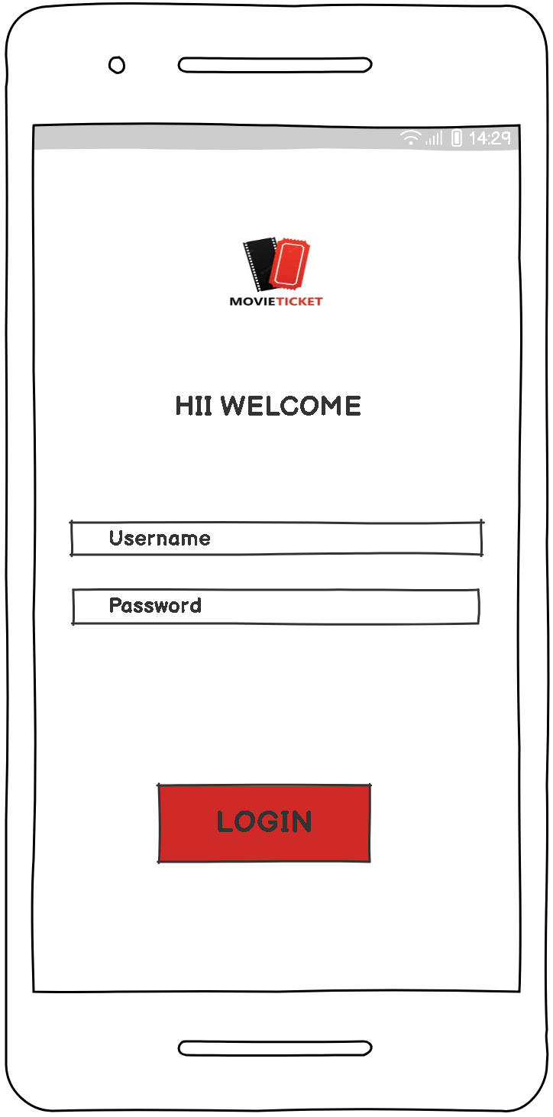

MOVIE SEARCH BAR:
The user he/she can search the movie what they want to watch or they can also book it for their comfortable.
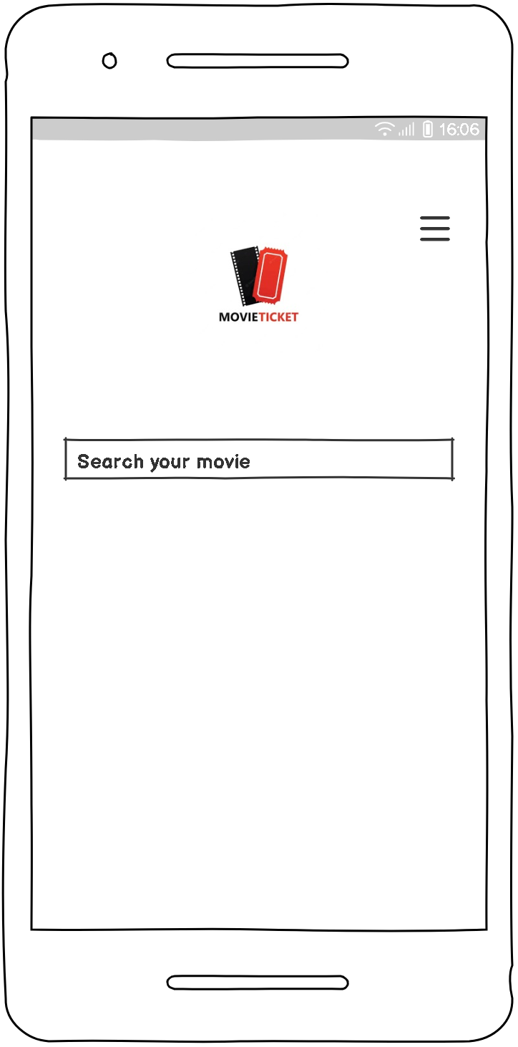

MOVIE LIST SHOWCASE:
After selecting a category or searching, the user is directed to the movie list screen. This screen displays available movies with a booking option.

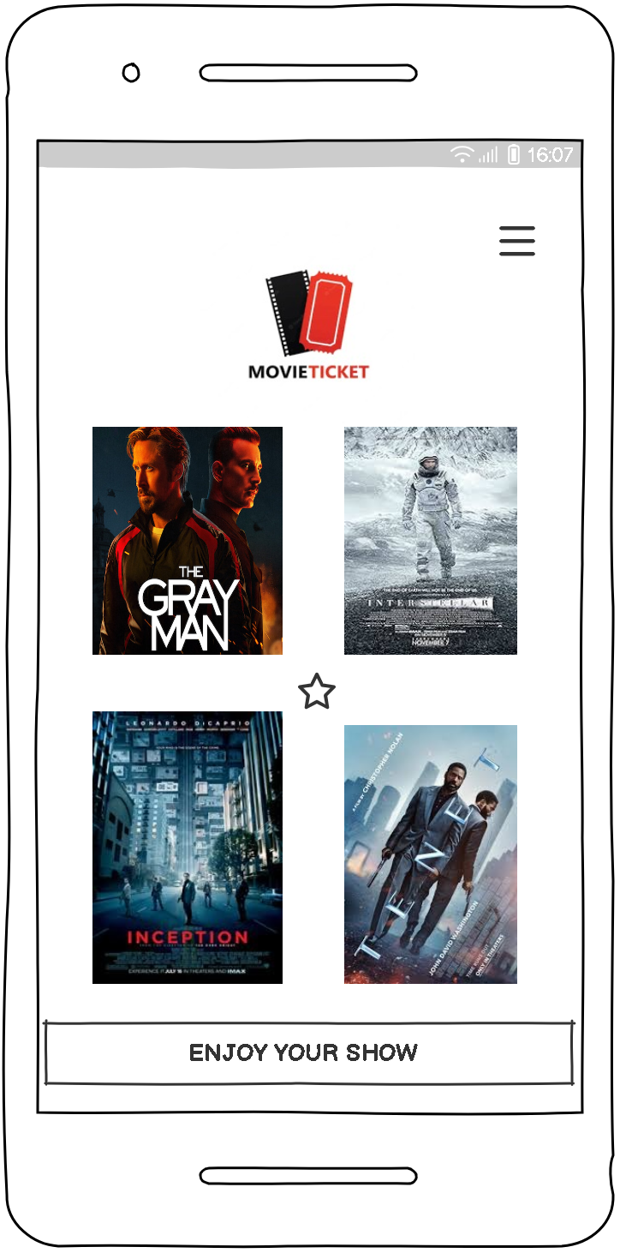

BOOKING SCREEN:
The booking screen allows users to select seats and confirm their booking. It ensures that users can proceed with ticket reservation easily.
